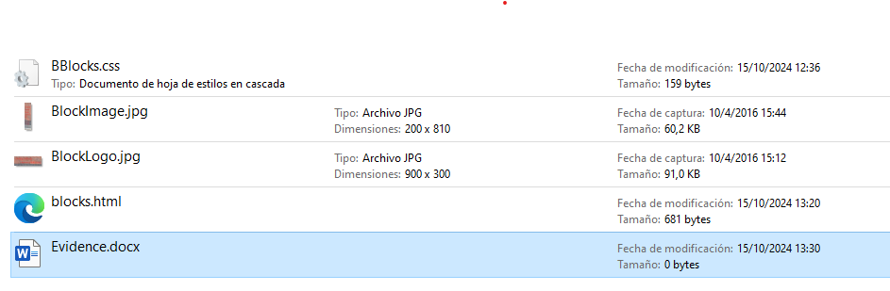

**Evidence 5**

The image does not maintain the aspect ratio